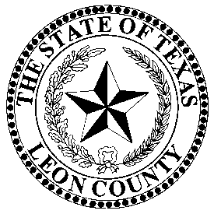 | LEON COUNTY ELECTION’S OFFICE
 | Donna Golden, Election Administrator, REO, CERA
 | P.O. Box 1239, 155 N Cass Street, Centerville, Texas 75833 903/536-4469 903/536-1773-FAX

May 4th, 2024, City/School Election School

We will be conducting a formal Election School for the upcoming May 4th, 2024 City/School Election on Wednesday, April 17th at 1:00 PM.

Donna Golden
Leon County Elections Administrator, REO, CERA
(903) 536-4469 Office
donna.golden@co.leon.tx.us

